為替手形の作成（L/Cなし）

 | Bill of Exchange
 | ① |  |  |  |  |  |  |  |  |  | ③
 | ②No.
 | ④For
 | ⑤At |  |  |  |  |  |  | sight of this F I R S T Bill of Exchange ( SECOND being
 | unpaid) Pay to ⑥ |  |  |  |  |  |  |  |  |  |  |  |  |  |  | or order
 | the sum of ⑦
 | Value received
 | ⑩To |  |  |  |  |  |  |  |  | KATO TRADING CO., LTD.
 |  |  |  |  |  |  |  |  |  |  |  | (Signed)
 |  |  |  |  |  |  |  |  |  |  |  | Manager

貿易資格情報局 ～Bon voyage～ |  | WEBサイト | LINEオープンチャット
 |  | 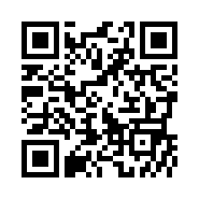 | 